Question 1
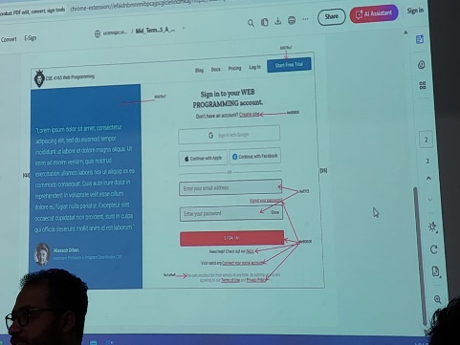
<!DOCTYPE html>
<html lang="en">
<head>
<meta charset="UTF-8">
<meta name="viewport" content="width=device-width, initial-scale=1.0">
<link rel="stylesheet" href="Style.css">
<title>Web Programming Log In</title>
</head>
<body>
<nav class="navbar">
<div class="navbar-left">
<img src="logo.png" alt="logo" class="logo" />
<span class="course-title">CSE 4165 Web Programming</span>
</div>
<div class="navbar-center">
<a href="#">Blog</a>
<a href="#">Docs</a>
<a href="#">Pricing</a>
<a href="#">Log In</a>
</div>
<div class="navbar-right">
<button class="trial-btn">Start Free Trial</button>
</div>
</nav>

<div class="container">
<div class="left-panel">
<p>Lorem ipsum, dolor sit amet consectetur adipisicing elit. Sapiente, itaque? Nulla nemo cumque expedita. Mollitia ea, ex nostrum nisi at explicabo, esse repellendus eligendi perferendis itaque animi, architecto sequi accusantium.</p>
<div class="profile">
<strong>Niassoh</strong><br>
<span>Assistant professor,cse</span>
</div>
</div>

<div class="right-panel">
<h2>Sign in to your <span class="highlight">web Programming</span>account.</h2>
<p class="small-text">Don't have an account?<a href="#">Create One</a></p>
<button class="social-btn">Sign in google</button>
<button class="social-btn">Continue with Apple</button>
<button class="social-btn">Continue with Facebook</button>

<input type="email" placeholder="Enter email">
<input type="password" placeholder="Enter password">
<div class="show-password">show</div>
<a href="#" class="small-text">Forgot password</a>
<button class="sign-in-btn">SIGN IN</button>

<p class="small-text">
Need help?Check out or <a href="#">FAQs</a>

</p>
<p class="small-text">

Visit our <a href="#">Connect Support</a> center. <br>

</p>
<p class="small-text">

By signing in, you agree to our <a href="#"> Terms of Service </a> and
<a href="#"> Privacy Policy </a>.
</p>
</div>

</div>

</body>
</html>

Qus1css
*{
margin: 0;
padding: 0;
box-sizing: border-box;
}
body{
font-family: Arial, sans-serif;
background: color #f1f1f1;;
}
.navbar{
display: flex;
align-items: center;
padding: 15px 40px;
background-color: white;
box-shadow: 0 2px 5px rgba(0, 0,0,0.1);

}
.navbar-left{
display: flex;
align-items: center;

}
.logo {
height: auto;
margin-right: 20px;
}

.course-title {
font-weight: bold;
font-size: 18px;
color: #0057a7;
margin-right: 20px;
}

.navbar-center a {
margin:0 8px ;

color: #333;
font-size: 16px;
}
.navbar-right .trial-btn {
padding:8px ;
background-color: #0057a7;
color: white;
border: none;
border-radius: 6px;
cursor: pointer;
font-size: 10px;
}
.trial-btn:hover {
background-color: #004080;
}

.container{
display: flex;
min-height: 100vh;
}
.left-panel{
width: auto;
background-color: #0057a7;
color: white;
padding: 40px;
display: flex;
flex-direction: column;
justify-content: center;

}
.left-panel h2{
margin-bottom: auto;
}
.left-panel p{
font-size: 16px;
line-height: 1.5;
}
.profile{
margin-top: 30px;
font-size: 15px;
}
.right-panel{
width: 60%;
background-color: white;
padding: 60px;
display: flex;
flex-direction: column;
justify-content: center;

}
.right-panel h2{
margin-bottom: 10px;
}
.right-panel .highlight{
font-weight: bold;
}
.small-text{
font-size: 15px;
margin: 10px 0;
}
.social-btn{
padding: 10px;
margin-top: 12px;
margin-bottom: 6px;
width: 100%;
border: 1px solid #ccc;
background-color: #fff;
cursor: pointer;
}
input{
padding: 10px;
margin-top: 12px;
width: 100%;
border: 1px solid #ccc;
border-radius: 4px;
}
.show-password{
font-size: 13px;
color: #007bff;
cursor: pointer;
margin-bottom: 12px;
}
.sign-in-btn{
padding: 12px;
background-color: #e50908;
color: white;
border: none;
font-weight: bold;
border-radius: 4px;
margin-top: 10px;
cursor: pointer;

}
.sign-in-btn:hover {
background-color: #c40807;
}
a {
color: #ff0800;
margin: 10px;
text-decoration: none;

}

